Summary of User Account Management

* User account management handles creation/deletion of profiles, logging in and update account information.
* The following requirements are the most pertinent to management for this overview:
  + The nutritional application shall **create a profile to** keep track of a user's nutritional information.
  + The nutritional application shall allow the user to password-protect their profile and progress information.

Use Case

* The use case covers both requirements of creating profiles and password-protection.
* Several requirements are also included in “Update User Account Information”. For the sake of brevity, these will be ignored.

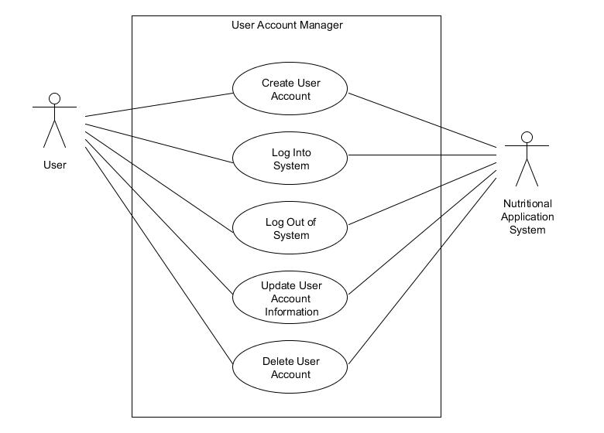

Activity Diagram

* The following is an activity diagram for login.
* At this point details emerge that demonstrate the workflow necessary to login.
* Traces to requirement that the user must be able to password-protect their profile.

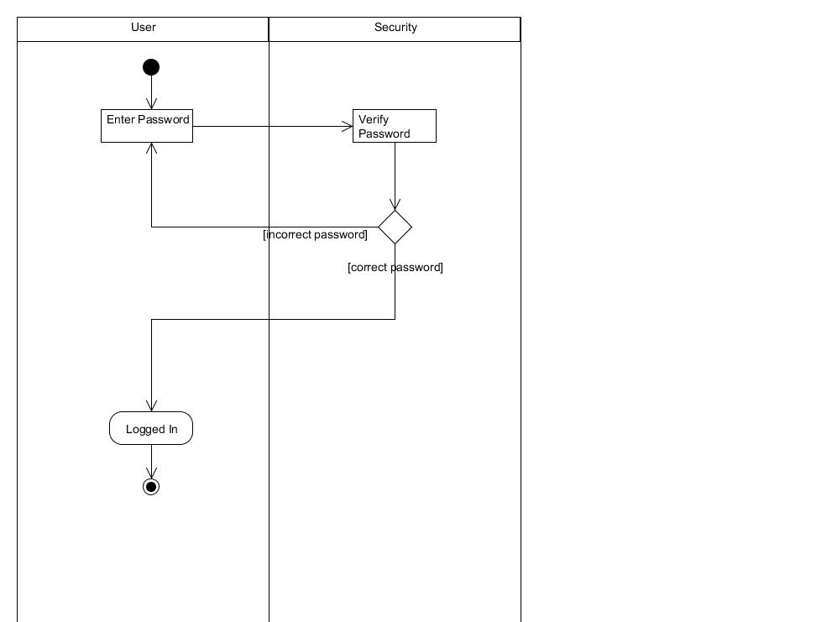

Sequence Diagram

* The following sequence diagrams detail the sequence of messages to create a profile and login.
* Traces to requirements of creating a profile and protection of the profile, respectively.

Create Profile SD Login SD

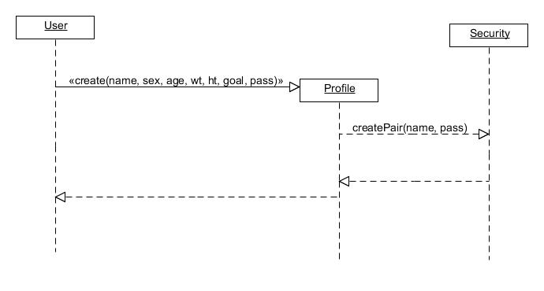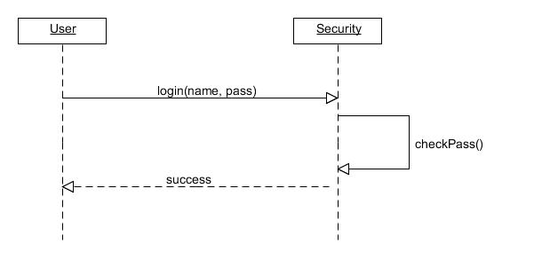

Class Diagram

* The following class diagram details associations and multiplicity for the class Profile.
* The diagram contains several fields that detail profile information and includes password, and as such it traces to the requirements.

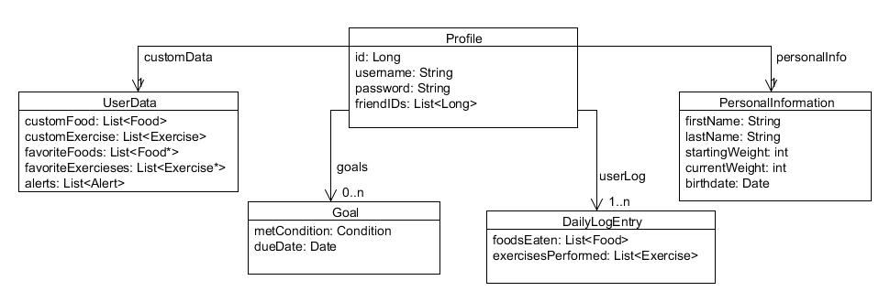

What Changed

* Across iterations several things changed, principally constraining or dropping some of the more grandiose features.
  + One such feature was an interface to a GPS.
* Initially there were separate concepts of account and profile. These concepts were merged.
* Across iterations one thing that needed to change was to make diagrams consistent and semantically closed. However, this goal is still being realized.